Lomonosov Moscow State University

International League of Young Scientists

International social organization for the promotion of civil society diplomacy,

scientific, educational and youth cooperation "Eurasian Commonwealth"

All-Russian youth social organization

"Russian Union of Student Organizations"

All-Russian Club of Young Researchers

Student Union of Lomonosov Moscow State University



## International Youth Scientific FORUM «Lomonosov-2021»

**28th International Scientific Conference for Undergraduate   
and Graduate Students and Young Scientists**

**«LOMONOSOV»**

***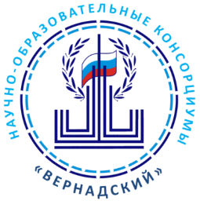*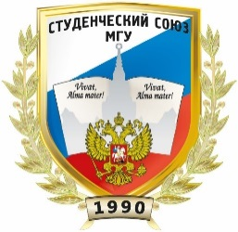**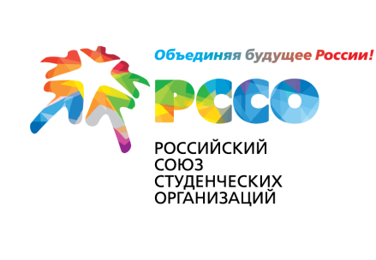

**INTERNATIONAL YOUTH  
SCIENTIFIC FORUM "LOMONOSOV-2021"  
includes the following main activities:**

* 28th International Scientific Conference for Undergraduate and Graduate Students and Young Scientists "Lomonosov" (February - April 2021);
* Regional platforms of scientific and educational consortia "Vernadsky" as a part of the   
  28th International Scientific Conference for Undergraduate and Graduate Students and Young Scientists "Lomonosov" (February - April 2021);
* "Lomonosov" Universiade (January - May 2021);
* The final stages of the High School Olympiads "Lomonosov" (February - April 2021);
* International competition for innovative projects and start-ups "Potential of the Future" (February - April 2021);
* International conference "Modern Technologies and Individual Educational Trajectories" (February - April 2021);
* Scientific lecture series (April 2021);
* International Congress for Young Scientists (February - April 2021);
* Eurasian Youth Forum "Eurasia – the Space of Cooperation, Peace and Harmony" (February - April 2021);
* International Space Forum dedicated to the 60th anniversary of the first manned space flight (February - April 2021).

Based on the decision of the organizing committee, other intellectual events for Undergraduate and Graduate students and Young scientists, student Olympiads (competitions), thematic interdisciplinary scientific conferences and competitions may be included in the Forum program.

**28th International Scientific Conference for Undergraduate and   
Graduate Students and Young Scientists "Lomonosov"**

**General Information**

1. 28th International Scientific Conference for Undergraduate and Graduate Students and Young Scientists "Lomonosov" will take place online at the Lomonosov Moscow State University from April 12 to April 23 2021 with possible offline participation (at the discretion of the organizing committees of the sections).

2. The working languages of the Conference are Russian and English. The Conference can be attended by Undergraduate and Graduate students and Young scientists from any country of the world under the age of 35 and less – students or employees of Russian or foreign universities, undergraduate and graduate students or employees of scientific institutions. A young scientist is a PhD student, teacher, or researcher – without a degree; Lecturer, Senior Lecturer, Researcher – with a PhD degree. Assistant professors, professors and Doctor of Science are not allowed to participate in the Conference, even if they are under 35 years old. If the work is done in co-authorship, each of the co-authors must meet the above requirements for Conference participants. Co-authorship with an academic advisor is not allowed, however the advisor can be mentioned in the acknowledgements. The allowed number of co-authors is determined by the organizing committee of a particular section.

3. Registration and abstract submission are open until March 9, 2021. Abstracts should be submitted via the electronic registration system on the Conference website –  
<https://lomonosov-msu.ru/eng/event/7000/>

4. The Conference will include the following scientific areas (sections):

|  |  |
| --- | --- |
| * **Art** * **Artificial Intelligence as an Innovative Digital and Social Resource for Public Administration** * **Asian and African Studies** * **Bioengineering and Bioinformatics** * **Biology** * **Broadcasting** * **Business Administration and Entrepreneurship** * **Business Management in the Digital Economy** * **Chemistry** * **Computational Mathematics and Cybernetics** * **Cultural Policy and Humanitarian Governance** * **Economics** * **Foreign Languages and Area Studies** * **Fundamental Materials Science and Nanomaterials** * **Fundamental Medicine** * **Geography** * **Geology** * **Globalistics and Geopolitics** * **History and Art History** * **Innovative Economics and Econometrics** * **Innovative Natural Resources Management** | * **Journalism** * **Law Sciences** * **Mathematics and Mechanics** * **Philology** * **Philosophy. Cultural studies. Religious studies** * **Physics** * **Political Science** * **Problems of preserving the cultural and linguistic diversity of the Russian Federation** * **Psychology** * **Public Administration** * **Public relations and theory of communication** * **Social Studies and Modernity** * **Sociology** * **Soil Science** * **Space Research in the Modern Context** * **State Audit** * **Teacher Education and Educational Technologies** * **Teaching Russian language and fundamental subjects to foreign students** * **Theory, History and Methodology of Translation** * **World Politics** |

5. For more information, visit the Conference website on the "Lomonosov" Scientific Portal – <https://lomonosov-msu.ru/eng/event/7000/>. The site provides general information about the Conference, the topic and structure of each section, the requirements for abstracts, the registration and abstracts submission system.

6. Selection of Conference participants, as well as the determination of the best reports of the Conference is carried out by the expert councils of the Conference sections. The expert councils of the sections consist of leading scientists of Lomonosov Moscow State University. Selected participants are invited no later than three weeks before the Conference.

**International competition for innovative projects and startups  
"Potential of the Future"**

The purpose of the Competition is to stimulate youth entrepreneurial activity and assist in finding investors for innovative projects and startups. The age of the participants is 35 years old or less.

The final round of the Competition will take place online on April 20 – 22, 2021. For more information, visit the Competition website – <https://lomonosov-msu.ru/eng/event/6632/>.  
The site provides general information about the Competition, the main project evaluation criteria, recommendations for preparing presentations, the registration and projects submission system.

**The international conference  
"Modern Technologies and Individual Educational Trajectories"**

The objectives of the Conference are to discuss strategies for building human capital for the economy in the context of developing a digital society and a changing careers landscape, as well as a presentation of career guidance practices and technologies.

The Conference will take place online on April 16 – 17, 2021. For more information, registration and abstracts submission, visit the Conference website –  
<https://lomonosov-msu.ru/eng/event/6633/>

**International Congress for Young Scientists**

The objectives of the Congress are: the development the International League of Young Scientists – an open system of interaction between academic youth from different countries, a discussion and implementation of modern formats for international scientific cooperation, presentation and launching of international projects and startups.

International Congress for Young Scientists will take place online on April 20 – 22, 2021.   
For more information, registration and projects submission, visit the Congress website – <https://lomonosov-msu.ru/eng/event/6634/>

**Eurasian Youth Forum  
"Eurasia – the Space of Cooperation, Peace and Harmony"**

On April 12 - 23, 2021, Lomonosov Moscow State University will host the Eurasian Youth Forum "Eurasia – the Space of Cooperation, Peace and Harmony" in an online format.  
The Forum program includes:

1. Plenary session.
2. Round table with the participation of representatives of youth organizations of the branch campuses of the Lomonosov Moscow State University.
3. Interdisciplinary sections for students, graduate students and young scientists of the branch campuses of the Lomonosov Moscow State University.

For more information and registration, visit the Forum website –  
<https://lomonosov-msu.ru/eng/event/6636/>

**International Space Forum,  
dedicated to the 60th anniversary of the first manned space flight**

On April 13 - 16, 2021, the International Space Forum, dedicated to the 60th anniversary of the first manned space flight will take place at Lomonosov Moscow State University.

The event will be held in-person and online. Distance participation in the event is not available.

Topics of the Forum:

* Mathematical models in space exploration
* Mixed reality in aerospace systems
* Actual problems of space industry management
* Issues of economics and law in the space industry
* Theoretical and applied problems of earth remote sensing
* Physics of the Solar System
* Astrophysics and radio astronomy
* Space instrumentation and experiment
* Theory and modelling of physical processes
* Exploration of planets

For more information and registration, visit the Forum website –   
<https://lomonosov-msu.ru/eng/event/6586/>

**Contact information:**

Forum "Lomonosov" organizing committee, 119991, Russian Federation, Moscow, Leninskiye gory, 1, Main building of Lomonosov Moscow State University, A-1023a.

E-mail: lomonosov@lomonosov-msu.ru